***Logging into the CMS – New users***

1. If you have never logged into the CMS before, you will first need to complete your User Profile. Open a browser (e.g., Internet Explorer or Firefox) and enter the following URL in the address bar: <https://cms.american.edu/newusers/login.cfm>.
2. Login using your my.american.edu username and password.

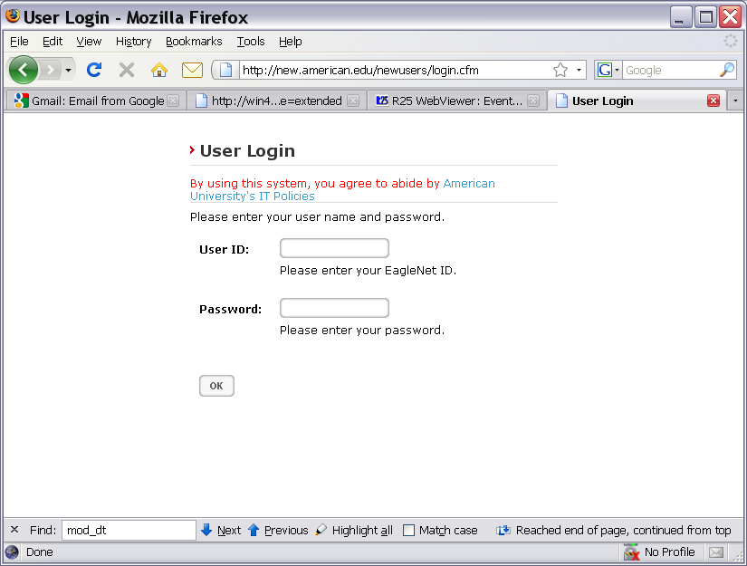

1. When you have logged in, select User Profile from the Page View menu in the upper right-hand corner.

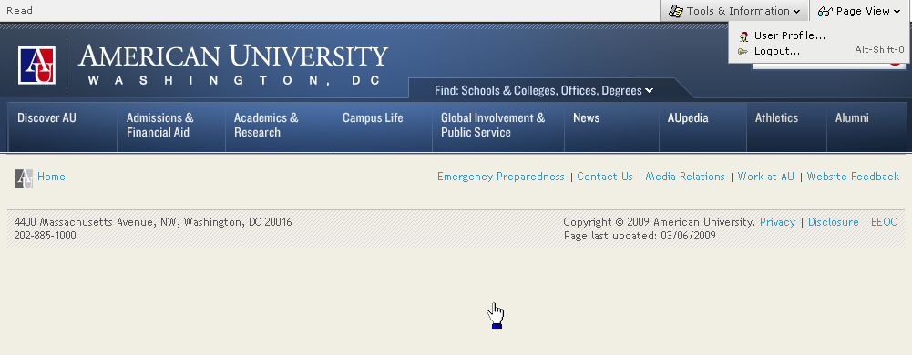

1. Complete the User Profile form. At a minimum, you must complete the First Name, Last Name, Organization, and Email fields. If you don’t find your exact organization listed, choose the closest “parent”.

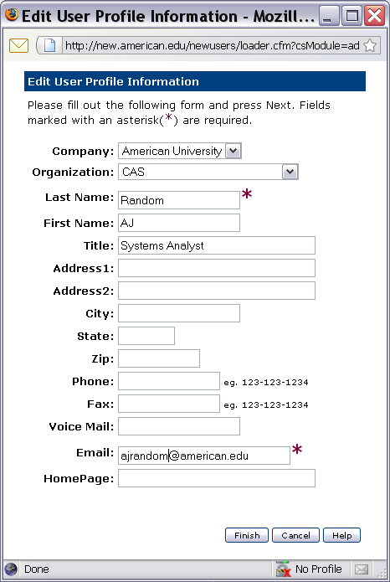

1. When you have completed your profile, click “Finish” to save it. Then logout out of the CMS by choosing Logout from the Page View button in the upper right corner of the page.

